



Project Name:

PG-DAC March-2023

Documentation On

**“Roster Management System”**

PG-DAC MARCH 2023

Submitted By :

**Group No: 06**

* **Name 1: Swapnil Pawar PRN No. 230343120057**
* **Name 2: Tanay Srivastava PRN No. 230343120095**
  + - **Name 3: Pawan Pawar PRN No. 230343120056**
    - **Name 4: Rhutik Salunkhe PRN No.230343120106**

**Table of Contents**

**1. Introduction 4**

1.1 Document Purpose **4**

1.2 Project Background **4**

1.3 Aim & Objectives **4**

**2. Business Requirements Overview**…………………………………………………………**5**

**3.Functional Requirements** **5**

3.1 Manager **5**

3.2 Transport Authority **5**

3.3 Employee/Driver **6**

**4.** **Non-Functional Requirement………………………………………………………………6**

**5. Use Case Diagram 7**

5.1 Manager **7**

5.2 Transport Authority **8**

5.3 Employee/Driver **9**

**6. Database Design 10**

1 users **10**

2 roster_details **10**

**7. E-R Diagram………………………………………………………………………………………12**

**8. Snapshots 13**

**9. Conclusion 22**

**List of Figures**

Use Case Diagrams 7

Fig 1 Admin 7

Fig 2 Supervisor 8

Fig 3 Employee/Driver 9

Fig 4 ER Diagram 12

1. **Introduction:**
   1. **Document Purpose:**

This document communicates the business requirements and scope for developing Roster Management System. The scope of this document is to define the functional and non-functional requirements, business rules and other constraints requirements.

## Project Background:

The Roster Management Service project aims to streamline Roster management in various industries by automating task assignment, providing real-time monitoring, and maximizing resource utilization. The goal is to enhance operational efficiency, improve service delivery, and offer comprehensive reporting while ensuring data security and scalability. The project addresses the challenges of manual task assignment, limited visibility, and inefficient reporting in the current systems, ultimately improving Roster management for organizations and stakeholders.

## Aim & Objectives:

The Roster Management Service project aims to enhance operational efficiency, improve service delivery, and maximize resource utilization by automating and streamlining the process of Roster management. The system will provide real-time task monitoring, implement intelligent task assignment, and offer comprehensive reporting and analytics. The project prioritizes user experience by providing a user-friendly interface and ensuring data security and privacy. Additionally, it will support scalability and seamless integration with existing systems, ultimately leading to improved efficiency, effectiveness, and service quality for the organization and its stakeholders.

1. **Business Requirements Overview:**

1. Automated Task Assignment: System automates task allocation based on Roster availability and skills.

2. Real-Time Task Monitoring: Supervisors monitor tasks in real-time for prompt decision-making.

3. Workload Balancing: System balances Roster workload efficiently.

4. Task Prioritization: High-priority tasks receive immediate attention.

5. Dynamic Task Reassignment: System supports seamless task reassignment.

6. Comprehensive Reporting: Detailed insights into Roster performance and task completion.

7. User-Friendly Interface: Intuitive interface for easy adoption.

8. Data Security: Robust measures to safeguard sensitive information.

9. Scalability and Integration: Easily scales and integrates with existing systems

# Functional Requirements Overview:

Roster Management Service consists of Three modules described as below.

1. Administrator
2. Supervisor
3. Employee

# 3.1. Administrator Module:

- The Administrator module provides centralized control over the Roster Management Service. Administrators have the authority to manage user accounts, assign roles, and define access permissions for Supervisors and Employees.

- Administrators can create and edit task categories, set task priorities, and define task templates for efficient task assignment and tracking.

- They have access to comprehensive reporting and analytics, allowing them to monitor system performance, user activity, and Roster productivity.

- The module enables administrators to manage system settings, such as data backup schedules, security configurations, and user authentication methods.

# 3.2. Supervisor Module:

- The Supervisor module empowers team leads and supervisors to oversee and optimize task assignments for Rosters.

- Supervisors can create, modify, and schedule tasks based on Roster availability, skills, and task priorities using the task templates defined by administrators.

- They can monitor real-time task progress, receive status updates from Rosters, and dynamically reassign tasks in response to changes or emergencies.

- The module provides task prioritization features, allowing supervisors to highlight critical tasks and ensure timely completion.

- Supervisors have access to basic reporting functionalities to track task completion rates and Roster performance.

# 3.3. Employee Module:

- The Employee module caters to the Rosters who carry out the assigned tasks. They can access the system to view their task assignments, update task statuses, and provide task-related feedback.

- Rosters receive notifications about new task assignments and any updates or changes to existing tasks.

- The module supports location tracking (if applicable), allowing Rosters to check in and out of work locations, enabling supervisors to make informed decisions about task assignments.

- Rosters can communicate with supervisors through the system, seeking clarifications or reporting issues related to tasks.

# 4. Non-functional Requirements

1. Professional Design: Visually appealing and consistent brand image.

2. Scalability: Handle 5-10k users and accommodate future growth.

3. Accessibility: Support different devices and web browsers.

4. Usability: Intuitive interface for a seamless user experience.

5. Security: Robust data protection and confidentiality.

6. Reliability: Highly available and reliable performance.

7. Compliance: Adhere to industry standards and data protection laws.

8. Mobile Responsiveness: Adaptive to various screen sizes and devices scalable platform for future growth.

## 5. Use-Case Diagram

**Administrator can access:**

**User Registration,**

**User Login,**

**User Management,**

**Configure System Settings,**

**Password Reset.**

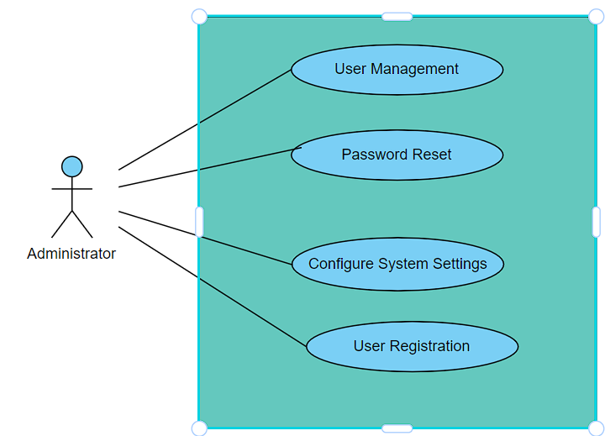

**Transport Authority can access**

**User Registration,**

**User Login,**

**Task Assignment,**

**Task Monitoring,**

**Task Prioritization,**

**Task Reassignment,**

**Task Reporting,**

**View Task Details,**

**Workload Balancing.**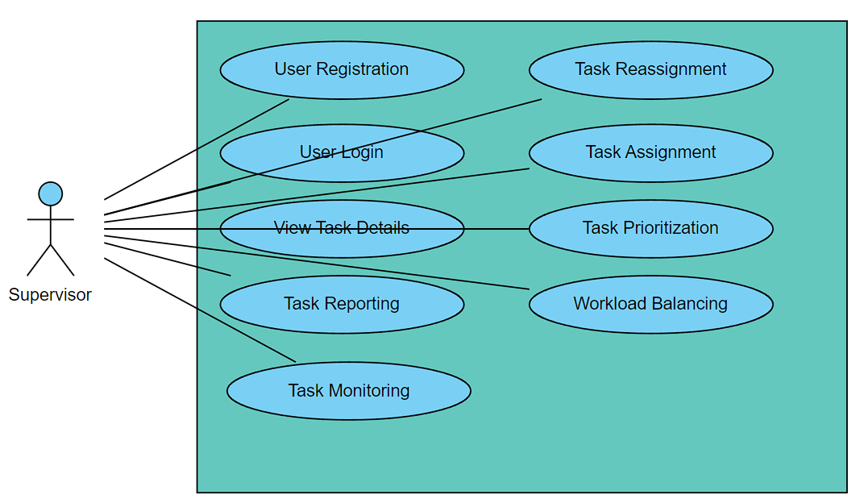

**Employee/Driver can access**

**User Registration,**

**User Login,**

**Task Monitoring,**

**Task Reporting,**

**View Task Details.**

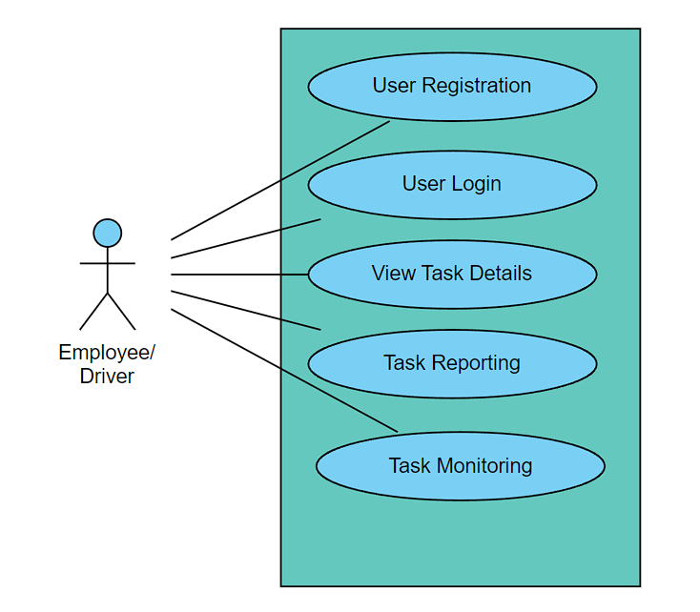

**6. Database Design:**

**1] Tbl_users**

|  |  |  |  |  |  |
| --- | --- | --- | --- | --- | --- |
| **Field** | **Type** | **Null** | **Key** | **Default** | **Description** |
| id | BigInt | No | Primary key | Null | User ID |
| email | Varchar(225) | No |  | Null | Email ID |
| password | Varchar(225) | No |  | Null | Password |
| role | Varchar(225) | No |  | Null | Type of User |
| username | Varchar(225) | No |  | Null | Username |

**2] Tbl_roster_details**

|  |  |  |  |  |  |
| --- | --- | --- | --- | --- | --- |
| **Field** | **Type** | **Null** | **Key** | **Default** | **Description** |
| empid | BigInt | No | Primary key | Null | Employee ID |
| date | Varchar(225) | No |  | Null | Date when employee is available |
| driver_date | Varchar(225) | No |  | Null | Date when driver is available |
| drop_time | Varchar(225) | No |  | Null | Timing of drop |
| emp_name | Varchar(225) | No |  | Null | Employee name |
| location | Varchar(225) | No |  | Null | Location for pickup |
| pickup_time | Varchar(225) | No |  | Null | Pickup time |
| shift_time | Varchar(225) | No |  | Null | Shift time |
| vehicle_number | Varchar(225) | No |  | Null | Vehicle Number |

## 7. ER-Diagram:

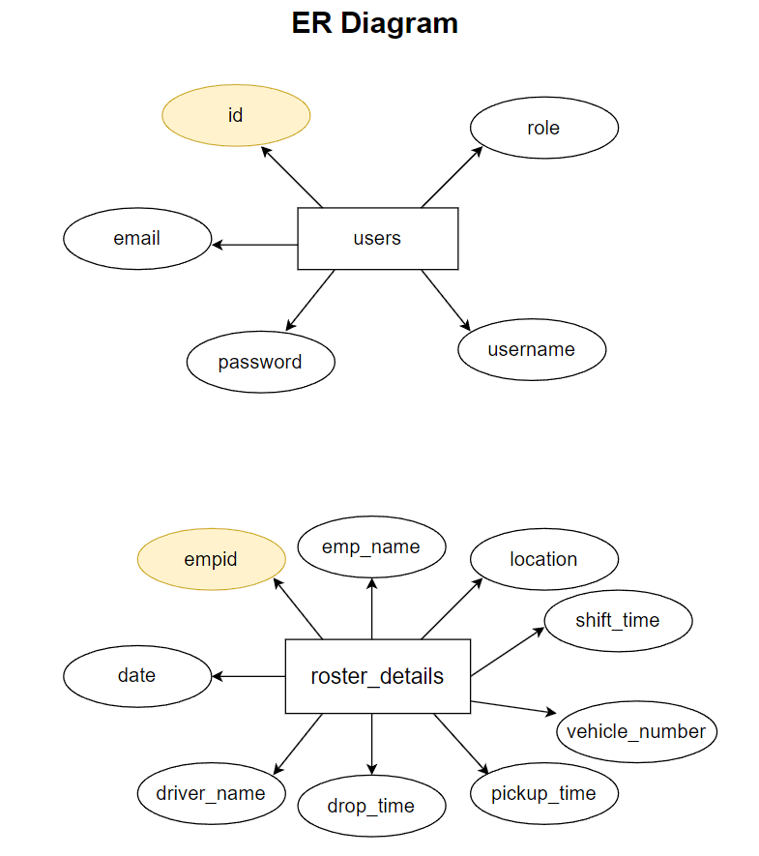

**E-R diagram shows database of Online PG Rental System**

**8. Snapshots:**

**This section will have snapshots of all the front end pages you are displaying in your project.**

**8.1 Home Page:**

This page contains following controls

* Login

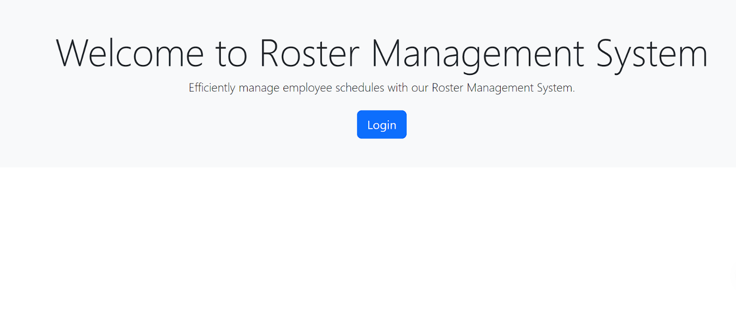

**8.2 Login Page**

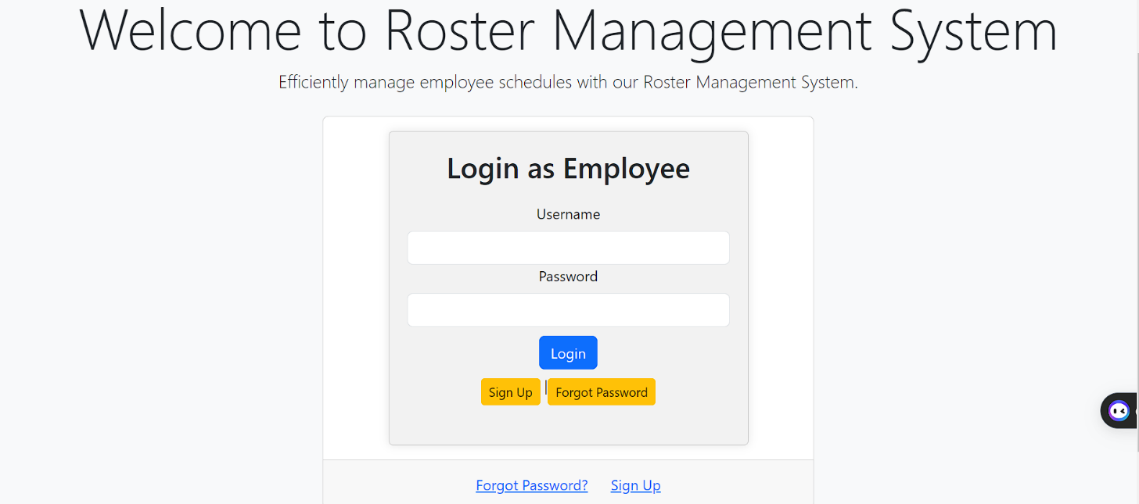

**8.3 Sign Up Page**

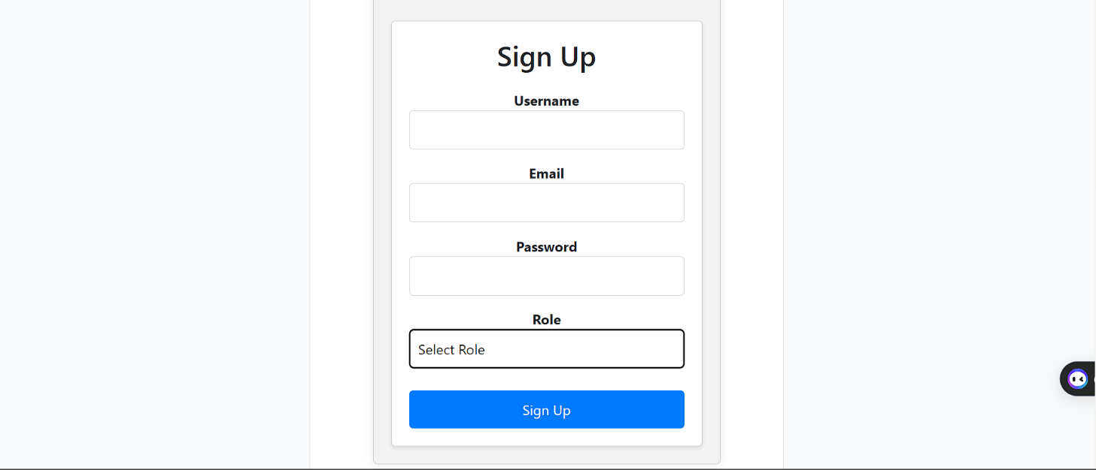

**8.5 Manager Page**

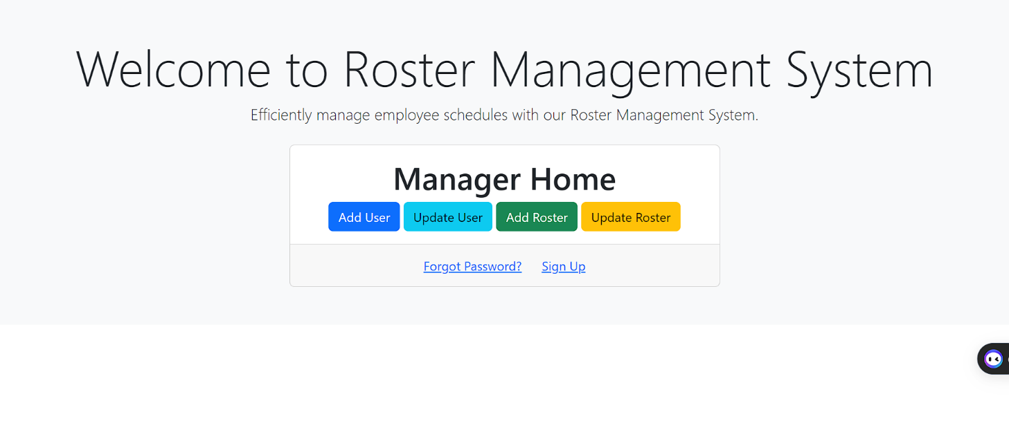

**8.5.1 Add User Page**

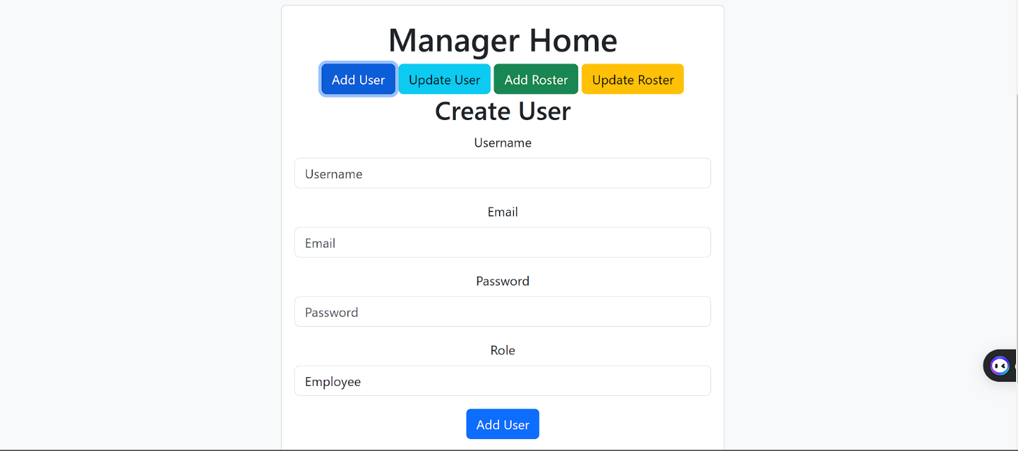

**8.5.2 Update User Page**

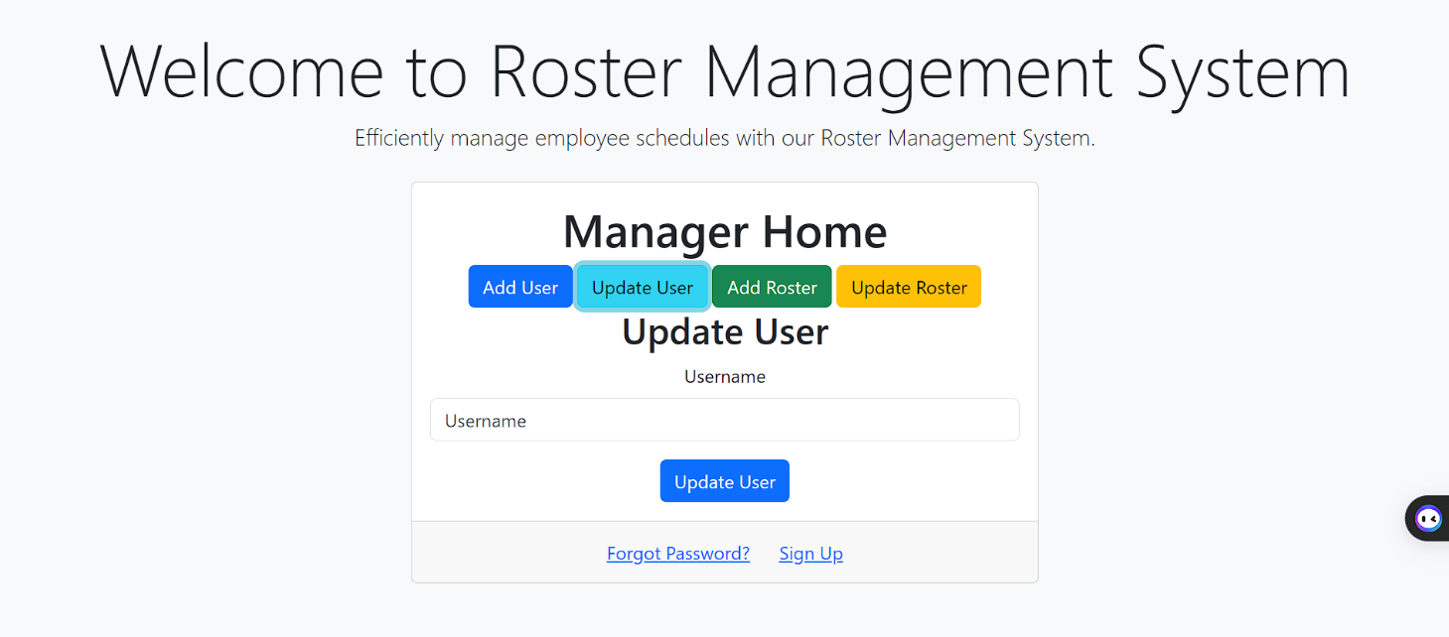

**8.5.3 Add Roster Page**

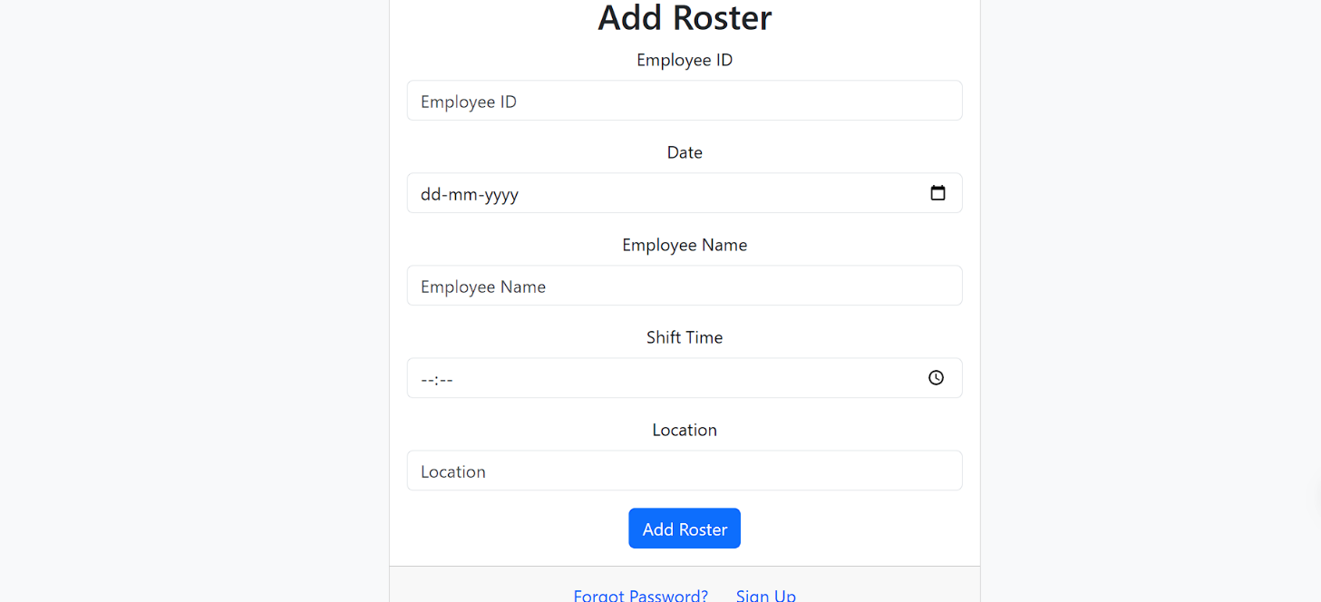

**8.6 Transport Authority Page**

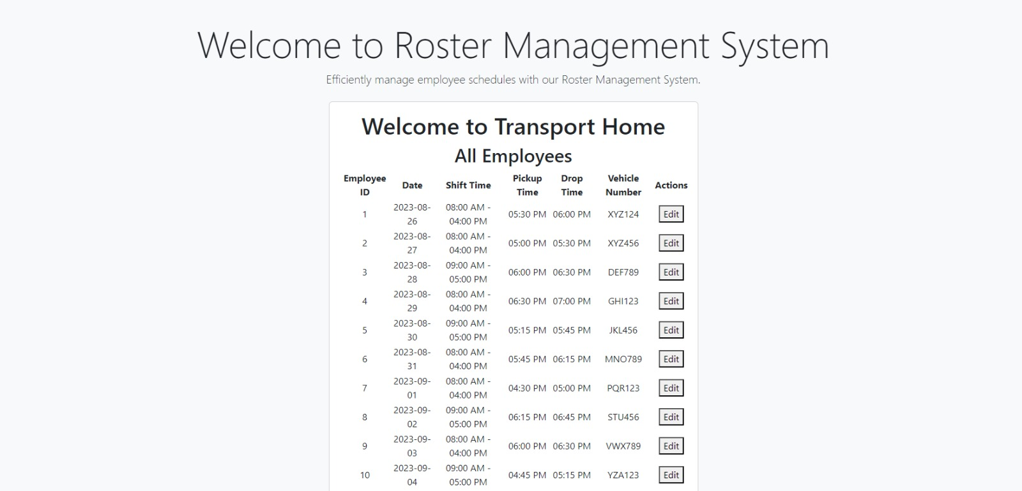

**8.6.1 Add/Update Roster List**

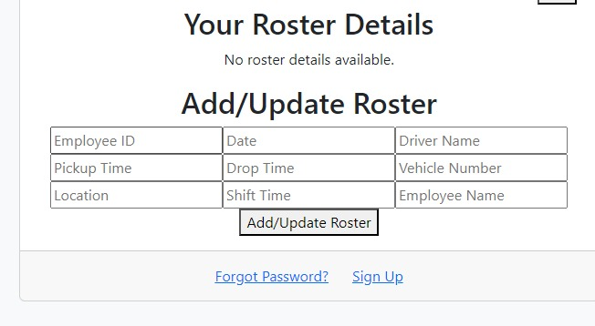

**9. CONCLUSION AND FUTURE SCOPE**

The Roster Management Service project represents a significant step forward in addressing the challenges faced by various industries in managing rosters efficiently. By automating task assignment, providing real-time monitoring, and offering comprehensive reporting, the project aims to enhance operational efficiency, improve service delivery, and maximize resource utilization. The user-friendly interface and focus on data security and scalability make it a valuable addition to organizations seeking to optimize their roster management processes. In conclusion, the Roster Management Service project has the potential to bring significant improvements to roster management in various industries. Its success can serve as a foundation for further innovation and development, ensuring that organizations continue to benefit from efficient, data-driven roster management solutions in the future.